How to do a breast self-exam: The five steps
Step 1: Begin by looking at your breasts in the mirror with your shoulders straight and your arms on your hips.  Here's what you should look for:  - Breasts that are their usual size, shape, and color  - Breasts that are evenly shaped without visible distortion or swelling  If you see any of the following changes, bring them to your doctor's attention:  - Dimpling, puckering, or bulging of the skin  - A nipple that has changed position or an inverted nipple (pushed inward instead of sticking out)  - Redness, soreness, rash, or swelling | 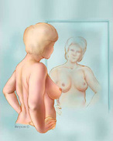  Breast Self-Exam — Step 1  Larger Version
Step 2: Now, raise your arms and look for the same changes.  Step 3: While you're at the mirror, look for any signs of fluid coming out of one or both nipples (this could be a watery, milky, or yellow fluid or blood). | Breast Self-Exam — Steps 2 and 3  Larger Version
Step 4: Next, feel your breasts while lying down, using your right hand to feel your left breast and then your left hand to feel your right breast. Use a firm, smooth touch with the first few finger pads of your hand, keeping the fingers flat and together. Use a circular motion, about the size of a quarter.  Cover the entire breast from top to bottom, side to side — from your collarbone to the top of your abdomen, and from your armpit to your cleavage.  Follow a pattern to be sure that you cover the whole breast. You can begin at the nipple, moving in larger and larger circles until you reach the outer edge of the breast. You can also move your fingers up and down vertically, in rows, as if you were mowing a lawn. This up-and-down approach seems to work best for most women. Be sure to feel all the tissue from the front to the back of your breasts: for the skin and tissue just beneath, use light pressure; use medium pressure for tissue in the middle of your breasts; use firm pressure for the deep tissue in the back. When you've reached the deep tissue, you should be able to feel down to your ribcage. | 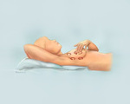  Breast Self-Exam — Step 4  Larger Version
Step 5: Finally, feel your breasts while you are standing or sitting. Many women find that the easiest way to feel their breasts is when their skin is wet and slippery, so they like to do this step in the shower. Cover your entire breast, using the same hand movements described in step 4. | 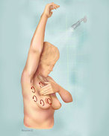  Breast Self-Exam — Step 5  Larger Version

